**Central Travel Agencies Management System**

***1.Designing (Entity Relationship) ER Diagram***

**Step-1: Identify the Entities Required**

There is a central management system for travel **Agencies**. Each agency will have a **Director**. Agencies will have many **Branches**. Travel agencies will have many **Agents**. Every travel agency will offer various travel **Packages**. Each package will have **Package info**. Each package will also have a **Tour_group**. Travel agencies will assign a tour **Guides** for each tour group. **Customers** will buy packages. They will do **Payment** to buy packages. Travel agencies will book any **transportation** for safely reach the customers to the travel place. Travel agencies will also book **Hotel** for the rest and refreshment of customers. After finishing the tour, customers can review **packages** and **agencies**.

**Step-2: Identify the Attributes and Primary key for each Entity**

1. agencies (agency_id, name, head_office, location, hotline, email)
2. director (director_id, name, contact, email)
3. branches (branch_id, name, address, contact)
4. agents (agents_id, name, contact, email)
5. packages (package_id, name, destination, cost)
6. package_info (info_id, starting_point, duration, description)
7. tour_group (group_id, name, descriptions, max_members)
8. guides (guide_id, name, phone, email, experiences)
9. customers (customer_id, name, address, contact, email)
10. payment (payment_id, amount, method, date, references)
11. transportation (transport_id, company_name, type, starting point, destination, hotline)
12. hotel (hotle_id, name, manager, contact, address, email)

**Step-3: Identify the Relationship needed**

1. directors -controls-agencies
2. agencies-establishes-branches
3. agencies-assigns-agents
4. agencies-offers-packages
5. packages-includes-package_info
6. package_info-includes-transportation
7. package_info-includes-hotel
8. packages-has- tour_group
9. guides-leades-tour_group
10. customers-chooses-packages
11. customers-completes -payment
12. customers-reviews-packages
13. customers-reviews-agencies

**Step-4: Draw the ERD Diagram**

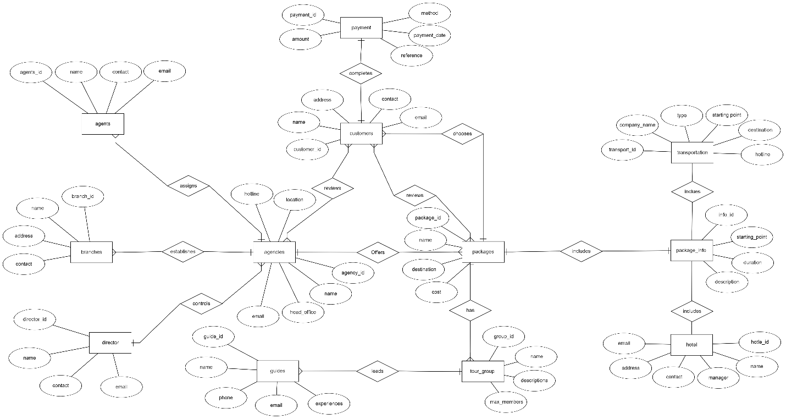

Figure: ERD Diagram for Central Travel Agencies Management System.

***2.*** ***Reduction to database schema:***

1. agencies (agency_id, name, director_id, head_office, location, hotline, email)
2. director (director_id, name, contact, email)
3. branches (branch_id, name, agency_id, address, contact)
4. agents (agents_id, name, agency_id, contact, email)
5. packages (package_id, name, agency_id, destination, cost)
6. package_info (info_id, package_id, starting_point, duration, description, transport_id, hotel_id)
7. tour_group (group_id, name, package_id, descriptions, max_members)
8. guides (guide_id, name, phone, email, experiences, group_id)
9. customers (customer_id, name, package_id, address, contact, email)
10. payment (payment_id, customer_id, amount, method, payment_date, reference)
11. transportation (transport_id, company_name, type, starting_point, destination, hotline)
12. hotel (hotle_id, name, manager, contact, address, email)
13. package_review (pr_id, customer_id, package_id, rating, comments)
14. agency_review (ar_id, customer_id, agency_id, rating, comments)